Practical 3

NAME: TASNEEM SADIKOT
PRN: 23070521162
SEM: 5 SEC: B

TASK1:
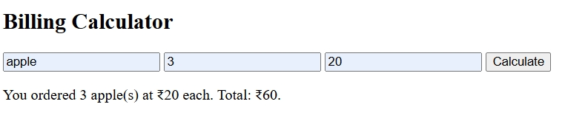
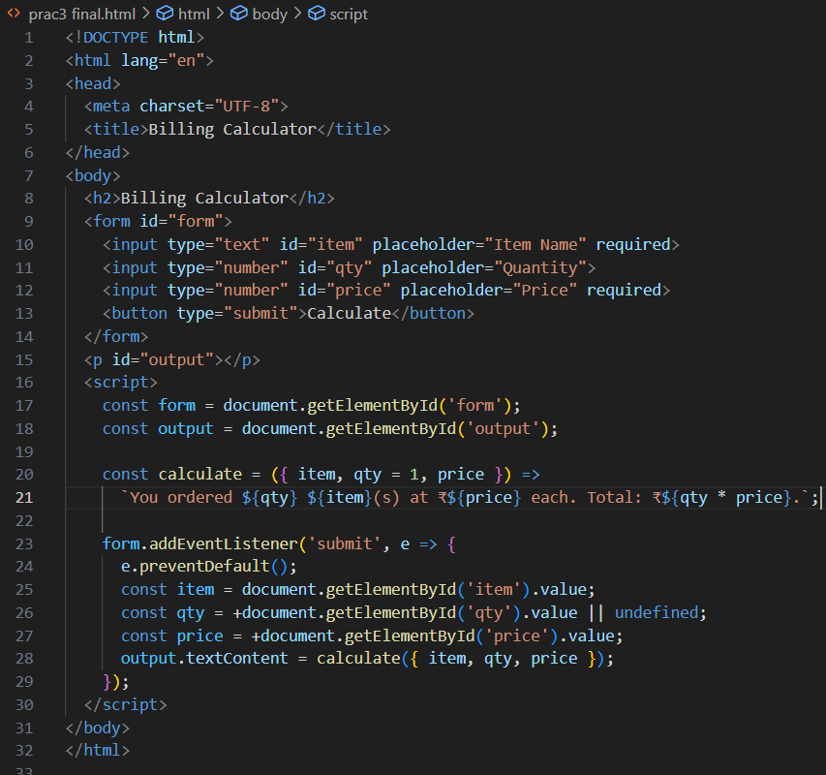

TASK2:
